Displaying Data From Multiple Tables Using Joins
- Write a query to retrieve EMPNO, ENAME, SAL, DNAME, and LOC using NATURAL JOIN.
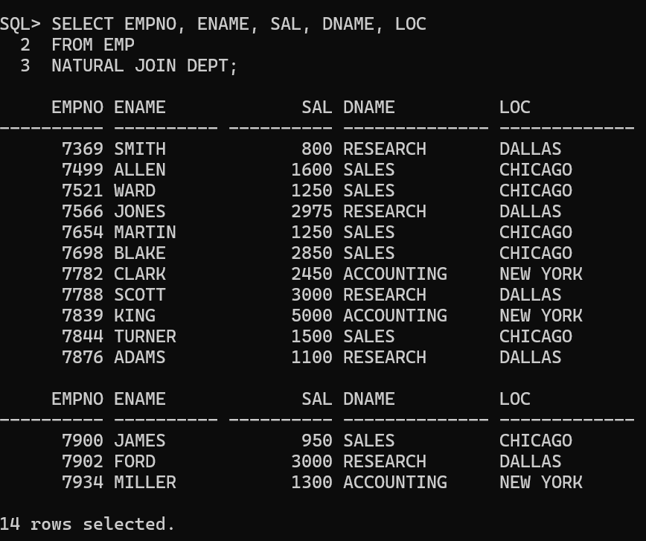

- Write a SQL query using EQUI JOIN to display the job, manager, salary, commission, and department name of Salesmen.
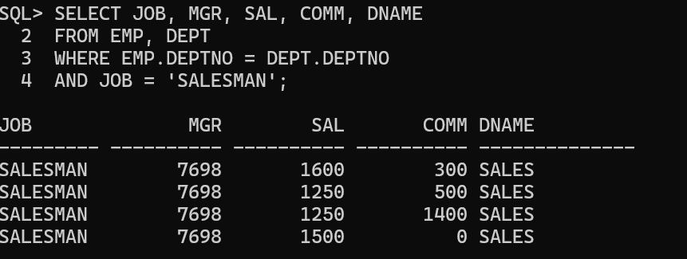

- Write a SQL query to display employees working in DALLAS.
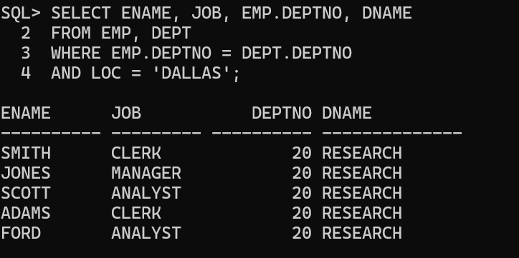

- Write a SQL query using SELF JOIN to display employee name, employee number, manager name, and manager number.
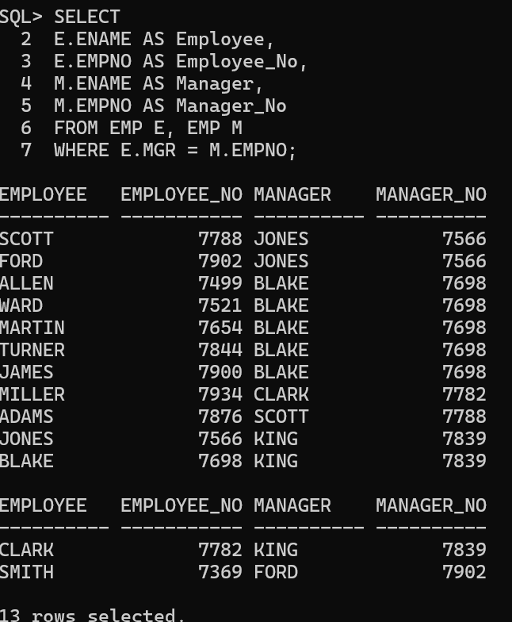

- Write a SQL query using OUTER JOIN to display all employees including KING (who has no manager).
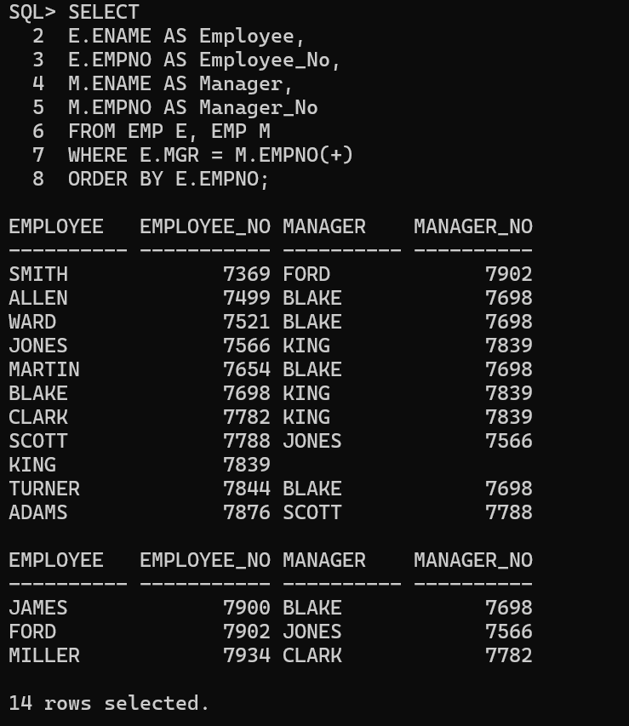

- Write a SQL query using NON-EQUI JOIN to display employee name, job, department name, salary, and salary grade.
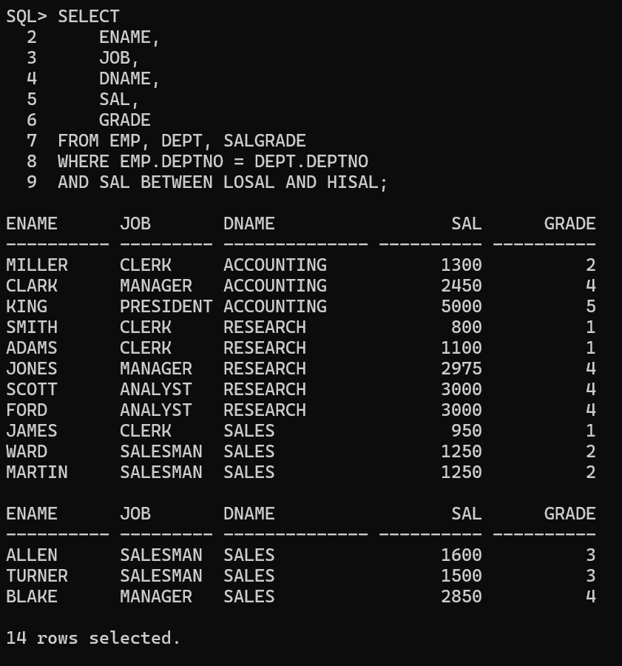

- Write a SQL query using RIGHT OUTER JOIN to display all departments, including those without employees.
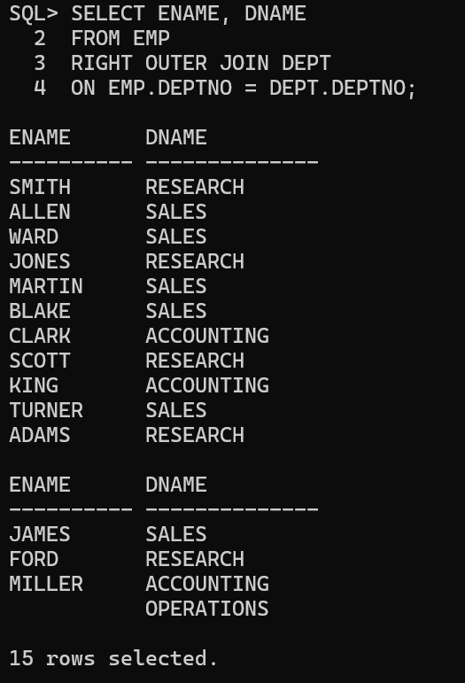

- Write a SQL query using SELF JOIN and OUTER JOIN to display employees hired before their managers.
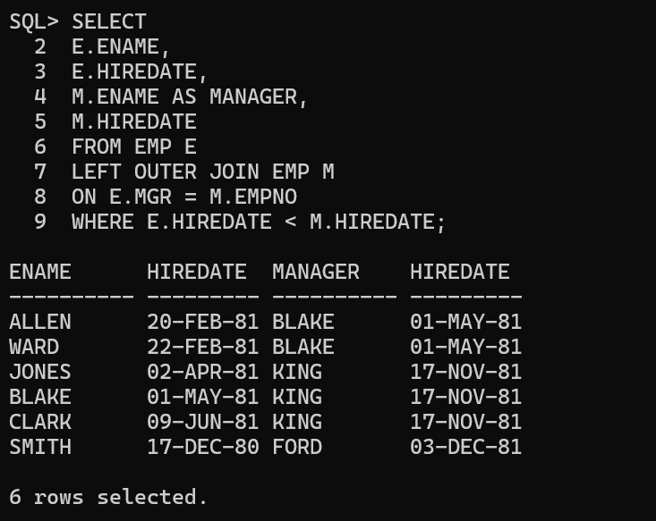

- Write a SQL query using the USING clause to display employee number, employee name, department name, and location of all Clerks.
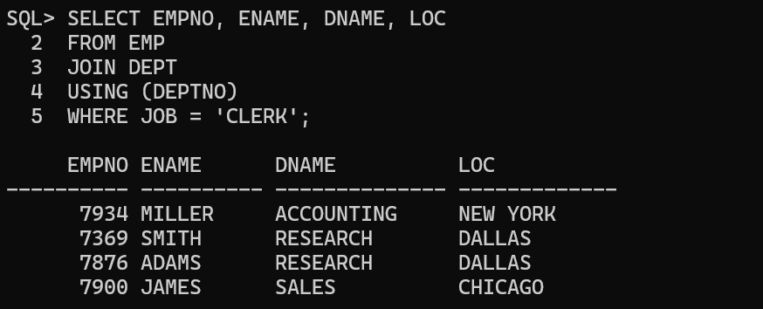

- Write a SQL query using the ON clause to display employee name, salary, manager, and department name for employees earning more than 2000.
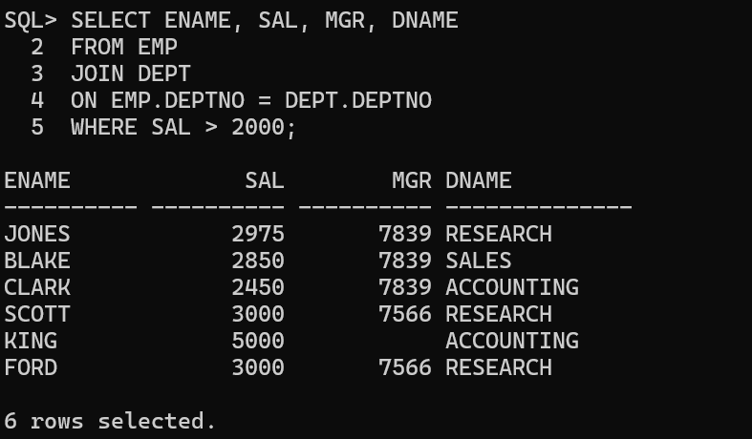

- Write a SQL query using LEFT OUTER JOIN to display employee number, employee name, job, department number, department name, and location.
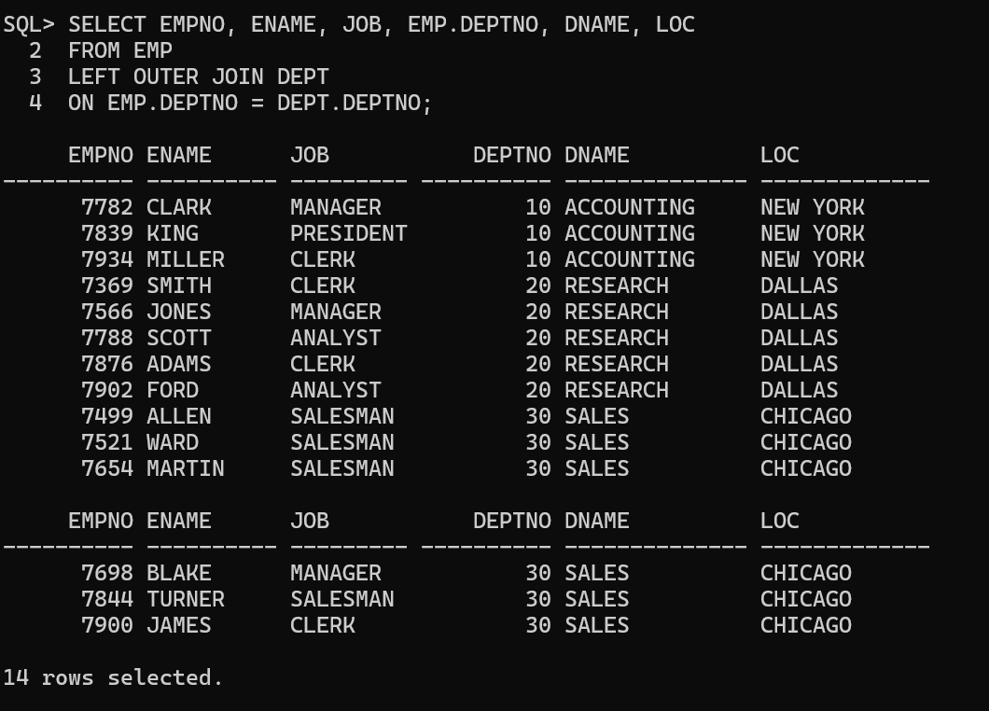

- Write a SQL query using RIGHT OUTER JOIN to display employee name and department name.
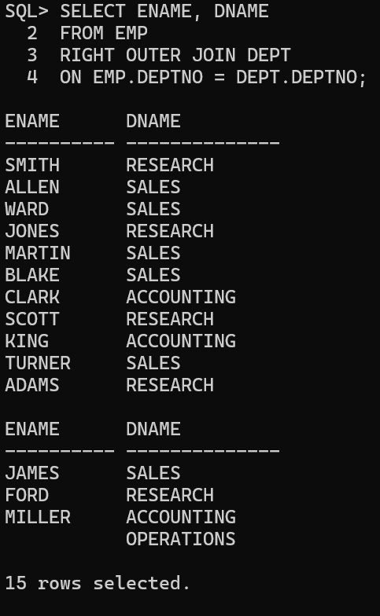

- Write a SQL query using FULL OUTER JOIN to display employee number, department name, and location.
